Hello and thank you for participating in the Langley HS Community Outdoor Yard Sale and Craft Fair!

Following are the details for a successful set up and day. Check-in will go quickly if everyone reads and follows these instructions. Please share this information with all of those coming to help you at the sale so they know what to expect.

The Langley HS Community Outdoor Yard Sale & Craft Fair will be held on Sunday, March 27th (rain date Sunday, April 10th) in the Langley High School parking lot (6520 Georgetown Pike, McLean, VA 22101). Selling hours are 8:00am – 2:00pm. Vendor check-in will be from 6:45am – 8:00am. Food and beverages will be on sale during the event.

Items to consider bringing:
- Table, chair, and/or whatever you need to set up your space and display your items
- For the crafters, vendor signage, flyers, business cards
- Something to keep money in (Fanny pack, apron with pockets or something attached to you)
- Small bills and change
- Shopping bags for your shoppers
- Sunscreen
- Tent/umbrella (must be secured with gallon jugs of water/bricks/or the like). Tents/umbrellas that must be spiked or pegged into the ground are NOT allowed
- Trash bags for clean up afterwards

Recommendations:
- Keep your money in a fanny pack and not in a money box left on a table.
- Bring a “counterfeit” pen or do not accept anything larger than a $20 bill
- In addition to cash, accept payments via PayPal and Venmo to attract more buyers.

Please note that there are no electrical outlets in the parking lot area where the event is being held. Moreover, we are not allowed to use the interior of the school, so extension cords cannot be run from inside the school out to seller’s locations

CHECK IN: The vendor’s check-in entrance is the West entrance to Langley High School (closer to the Georgetown Pike-Langley Oaks light). Look for the yellow yard signs. Check in will occur along the slip road in front of the main entrance to Langley High School (parallel to Georgetown Pike). After checking in, turn left into the main parking lot to find your space. (See photo at end of document.)

To help make check in run smoother, print you LAST NAME in large letters on a piece of paper and put it on the dashboard on the driver’s side so we can see it when you pull in. Please let me know if you are using more than one vehicle to transport your goods. If you are using two or more vehicles at check-in, please use the last name of the person who reserved the vendor spot.

The minimum ‘space’ purchased will be equivalent to 2 parking spaces. You will be given your space assignment upon arrival. Pull your car as close to your assigned space as possible and leave room for cars to pass you. Do not pull into the parking space. Vendor spaces will be designated by rows – A through C. Each vendor will receive an assigned alpha-numeric code, such as row A space 1, during check-in.

Participants assigned to row “A” will use the Kiss & Ride Lane to park and set up. Participants assigned to Row “B” will use the lane between rows A and B to park and set up. Participants assigned to Row “C” Will use the lane in front of their row to drive and unload (see photo at end of this document).

Be aware that cars will be stacking up with those also needing to unload. Get as close to your space as possible, allowing cars to pass you. Unload your car quickly, then move it to the parking area. PLEASE DO NOT SET UP AS YOU ARE UNLOADING. Only one car at a time can unload at your space. If you have more than one car, unload one then move it to the parking area before bringing the second car in to unload. All cars must be unloaded and out of the sales area by 8:15AM.

Staff/Volunteers will be wearing traffic vests & directing traffic. The vending area will be blocked off during sale hours. No cars will be permitted to drive into the sales area after 8:15am or before 2:00pm.

For those working the yard sale alone, let me know if you would like staff/volunteer to stop by your booth to offer you a restroom break or if assistance is required to carry or move large/heavy objects.

Parking: After unloading, drive to the back of the parking lot, closer to the athletic fields. Do not park in the two lanes next to/behind the football stadium. Local sports team will use the field during the day, and those drivers will park in the spaces closest to the field. After the sale, drive your car back into the sales area the opposite way you drove out so that all the cars are facing one way. Be sure to get close to your space so cars can pass you. Cars will not be permitted back into the sales area until 2:00pm.

If there are heavy rains or excessive rain threatens, I will send an email and/or text message to the contact information you provided when you signed up. In addition, check the ANGP2022 webpage – https://www.ptsalangley.org/yard-sale-and-craft-fair - for an update. The rain date is Sunday, April 10 in the same place and same time.

We will make every attempt possible to keep out the ‘early bird’ shoppers by having volunteers at the parking lot entrance. I ask that you also do not shop at other vendor's spaces until after 8:15am to allow everyone ample time to set up.

Restrooms: The restrooms on the side of the Snack Shack in the football stadium will be open for use during the event. We are not allowed into the school

Trash: MOST IMPORTANTLY - Clean up your space when you are done. Bring large trash bags and plan to take your trash out with you. PLEASE do not leave ANY trash/empty boxes/paper/bags/etc behind. The high school does not have the capacity to handle above normal trash levels. Thank you for your understanding.

For yard sale participants, the Langley ANGP committee will collect unsold clothing, soft items, books, and small, gently used household goods to donate to charitable organizations. We CAN NOT take furniture. ANGP committee members will start collecting these items at 1:30pm near the check-in area in the front of the parking lot. Tax donation receipts will be provided. DO NOT just leave items behind in your seller’s space after the event.

Food: The Langley ANGP will hold a bake sale. In addition, food trucks will start arriving at 10:00am. Participating food trucks are Babu Ji Mediterrean & Halal, Captain Pell’s Seafood, Killer Tomato Wood Fired Pizza, and The Inside Scoop mobile ice cream parlor.

If you have questions and/or specific suggestions you want to discuss, I will be happy to discuss them with you.

Regards,
Annette Bellino
Annette.bellino@verizon.net

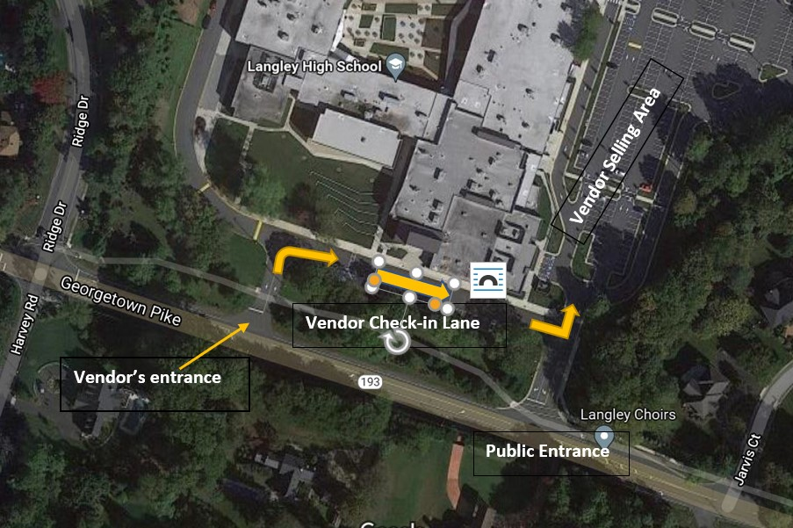
Vendor Check In Map

